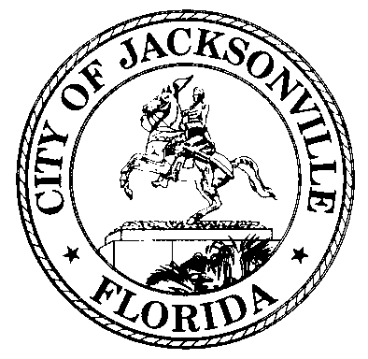

Legislative Services Division
City Hall - 4th Floor, Suite 430
117 West Duval Street
Jacksonville, Florida 32202

July 8, 2019

NOTICE OF PUBLIC HEARING

You have received this notice because you are either: the appellant, a person who submitted Speaker Cards/Provided Written Statement, or you appeared at the Planning Commission public hearing for WLD-19-13:

RESOLUTION 2019-461

A RESOLUTION CONCERNING THE APPEAL FILED BY MALIH PROPERTIES, LLC (BANNER LIQUOR, INC.), OF A FINAL ORDER ISSUED BY THE PLANNING COMMISSION DENYING APPLICATION FOR ZONING WAIVER OF MINIMUM DISTANCE REQUIREMENTS FOR LIQUOR LICENSE LOCATION WLD-19-13 REQUESTING TO REDUCE THE REQUIRED MINIMUM DISTANCE BETWEEN A LIQUOR LICENSE LOCATION AND A CHURCH OR SCHOOL FROM 500 FEET TO 400 FEET ON PROPERTY LOCATED AT 4250 MONCRIEF ROAD, PURSUANT TO SECTION 656.141, ORDINANCE CODE; ADOPTING RECOMMENDED FINDINGS AND CONCLUSIONS OF THE LAND USE AND ZONING COMMITTEE; PROVIDING AN EFFECTIVE DATE

As required by the Ordinance Code, a public hearing concerning this legislation has been scheduled for Wednesday, September 4, at 5:00 p.m. before the Land Use & Zoning Committee in the City Council Chambers, 1st Floor of City Hall, 117 West Duval Street, Jacksonville, Florida.

All persons wishing to speak to this legislation should appear at the above meeting. (Procedure: All testimony will be heard, and this committee recommends a proposed final action to the full City Council. The Planning and development Department and applicant/representative should be present with information.)

Copies of the application, Planning and Development's staff reports and public comments are maintained by the Department and the City Council Legislative Services Division and are open to public inspection. All interested persons wishing to submit testimony, written comments or other evidence relative to this application should submit same to the City Council Legislative Services Division and/or appear at the public hearings. Citizen input at the public hearing is encouraged by the city.

If you have any questions or need additional information about this appeal, please contact Jessica Matthews at (904) 255-5122 or jmatthews@coj.net

